**EC2 Instances: [virtual server]**

An EC2 instance is a virtual server in Amazon's Elastic Compute Cloud (EC2) for running applications on the Amazon Web Services (AWS) infrastructure.

EC2 can store 2 different locations EBS and instance store memory. Data don’t persist in Instance Store Memory so once server off, data will be lost.

By default, we have 20 instances per EC2 region with two default high I/O instances.

Types:

1. **General purpose:** Balanced Memory and CPU.
2. **Compute optimized:** More CPU than RAM.
3. **Memory optimized:** More RAM
4. **Accelerated Computing/ GPU:** Graphics Optimized
5. **Storage Optimized:** Low Latency
6. **High Memory Optimized:** High RAM, nitro system

**AMI [Amazon Machine Image] :** Pre-configured templates

An AMI is a template that contains the software configuration (operating system, application server, and applications) required to launch your instance. You can select an AMI provided by AWS, our user community, or the AWS Marketplace; or you can select one of your own AMIs.

Example: Window server, Linux server, Apache server, SQL server etc.

**Instance Type:**

Instances are virtual servers that can run applications. They have varying combinations of CPU, memory, storage, and networking capacity, and give you the flexibility to choose the appropriate mix of resources for your applications.

**Security Group:**

A security group acts as a virtual firewall for your instance to control incoming and outgoing traffic. ... When Amazon EC2 decides whether to allow traffic to reach an instance, it evaluates all of the rules from all of the security groups that are associated with the instance.

**Region and Availability Zones and Local Zones:**


    Regions, Availability Zones, and Local Zones
   

Each Region is a separate geographic area. Each Region has multiple, isolated locations known as Availability Zones. Each Availability Zone is isolated, but the Availability Zones in a Region are connected through low-latency links.

A Local Zone is an extension of a Region that is in a different location from your Region. Local Zones provide you the ability to place resources, such as compute and storage, in multiple locations closer to your end users.

**VPC:**

 A virtual private cloud (VPC) is a virtual network dedicated to your AWS account.

**Subnet:**

A subnet is a range of IP addresses in your VPC. A route table contains a set of rules, called routes, that are used to determine where network traffic is directed.

# EBS Amazon Elastic Block Store (EBS) is a block storage system used to store persistent data. Amazon EBS is suitable for EC2 instances by providing highly available block level storage volumes. It has three types of volume, i.e. General Purpose (SSD), Provisioned IOPS (SSD), and Magnetic.

**EBS Snapshot:**

Amazon Elastic Block Store (Amazon EBS) is a service that provides persistent block-level storage for Amazon Elastic Compute Cloud (Amazon EC2) instances. Simply speaking, the service allocates reliable hard drives (aka volumes) to cloud servers. One of the very useful features of Amazon EBS is creating snapshots of EBS volumes. According to Amazon Knowledge Base, AWS EBS snapshots are backups of EBS volumes

What Is EBS Snapshot?

An EBS snapshot is a point-in-time copy of your Amazon EBS volume, which is lazily copied to Amazon Simple Storage Service (Amazon S3). EBS snapshots are incremental copies of data. This means that only unique blocks of EBS volume data that have changed since the last EBS snapshot are stored in the next EBS snapshot. This is how incremental copies of data are created in Amazon AWS EBS Snapshot.

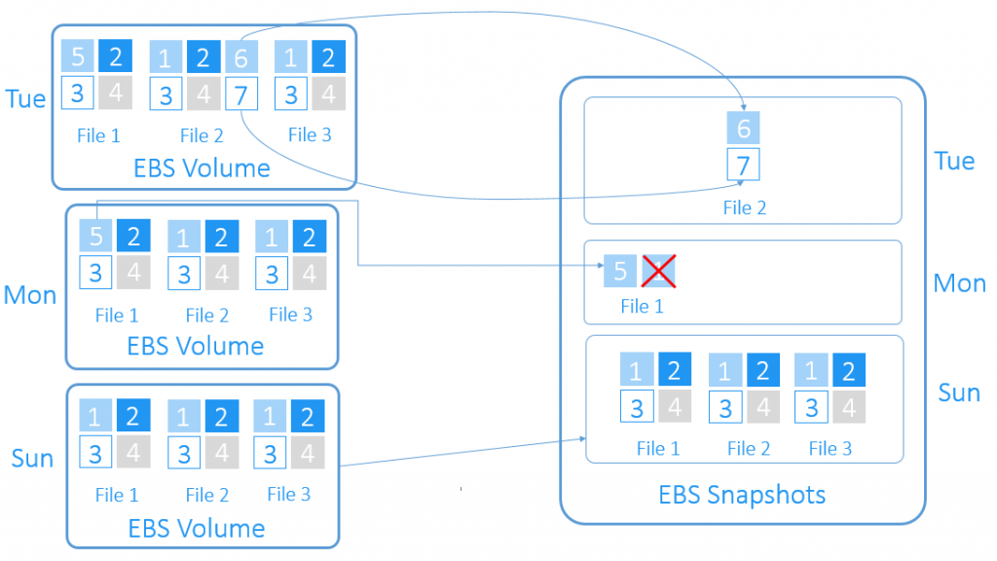

Each AWS snapshot contains all the information needed to restore your data starting from the moment of creating the EBS snapshot. EBS snapshots are chained together. By using them, you will be able to properly restore your EBS volumes, when needed.

Deletion of an EBS snapshot is a process of removing only the data related to that specific snapshot. Therefore, you can safely delete any old snapshots with no harm. If you delete an old snapshot, AWS will consolidate the snapshot data: all valid data will be moved forward to the next snapshot and all invalid data will be discarded.

Topics: EC2, instance store memory, EBS, EBS snapshots, AMI, Region, AZ, Local Zone, Security Groups, VPC, Subnet